**Friday 28 June**

You can find last week's newsletter here

## **Goals**

**Stylized Mill Project**

* Create Video Reel Plan + Plan Ahead
* Model Ruins & 2 New Stone Assets
* Create New Level Sequence in UE5 (2)
* List Feedback received from peers

**Online Store**

* Create 14 – 21 New Product Listings for this week
* Watch Content HiiamAaron (On Patreon)

## **Video Reel Plan**

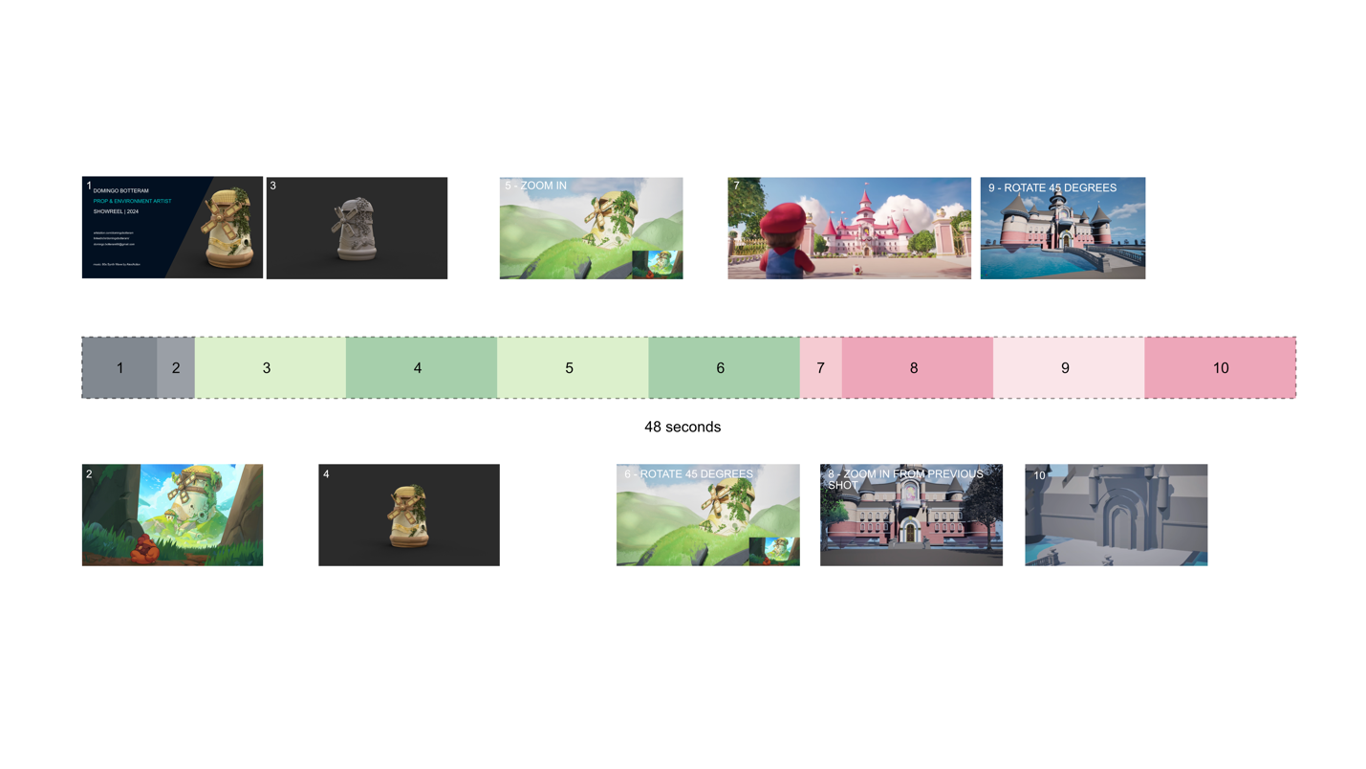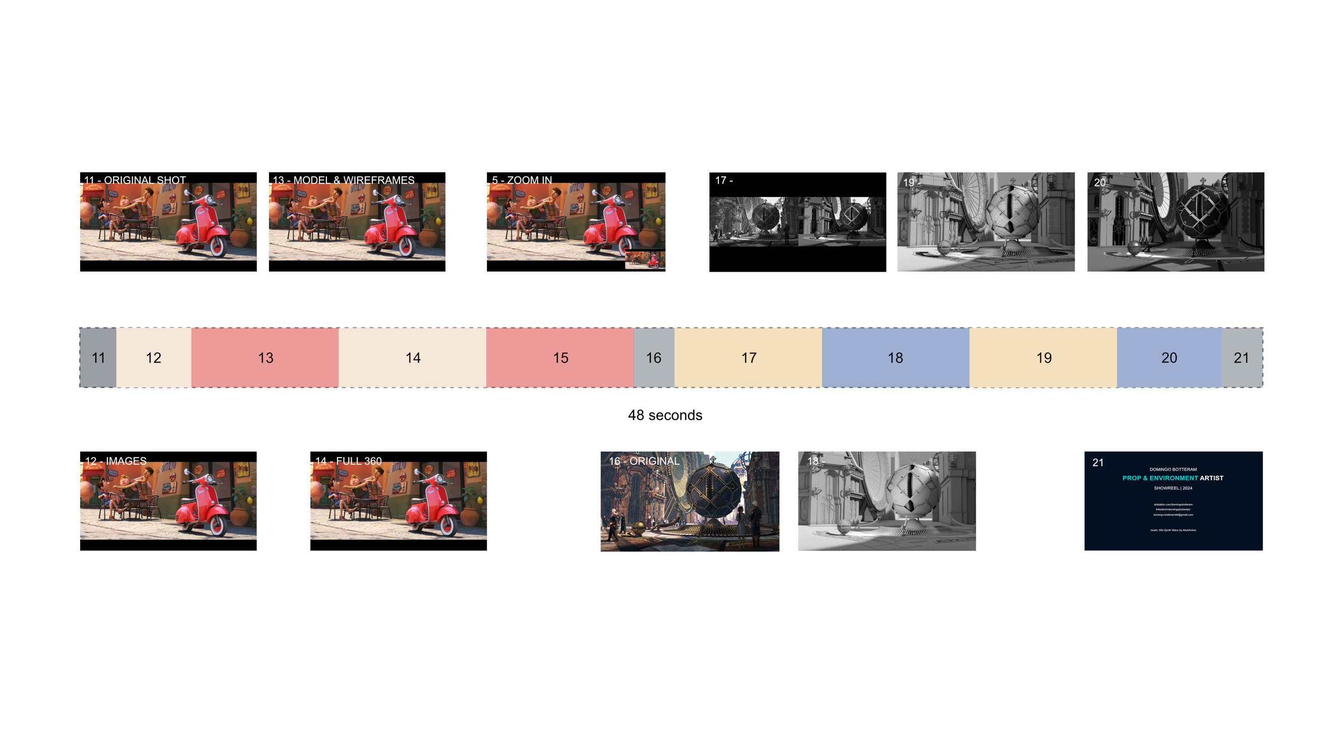

First few frames are going to be from the most recent project the Stylized Old Mill, then following is Peach’s Castle (that still needs to be finished in terms of texturing), Then the Vespa scooter will be completely created + small environment. Finally, we close off with the project from last year (2023) The city of Iron.

**Model Ruins & 2 New Stone Assets**

Ruins & new rocks have been modelled and imported into UE5. They seemed to be really big, so had to make them 25% smaller so they could be fit into the environment. Also the creation of the texture was fairly simple. I’ve picked the colours from the original reference, but it seemed too much green. So, instead I colour picked the same colours from the mill.

**Analysis Online Store**

Create 14 - 21 New Product Listings [Online Store]

Working on Online Store (Product Listing & Learning)

This week I’ve sold these products with a total profit margin off:

|  |  |  |  |  |  |  |  |  |
| --- | --- | --- | --- | --- | --- | --- | --- | --- |
|  |  |  |  |  |  |  |  |  |
|  |  |  |  |  |  |  |  |  |
|  |  |  |  |  |  |  |  |  |
|  |  |  |  |  |  |  |  |  |